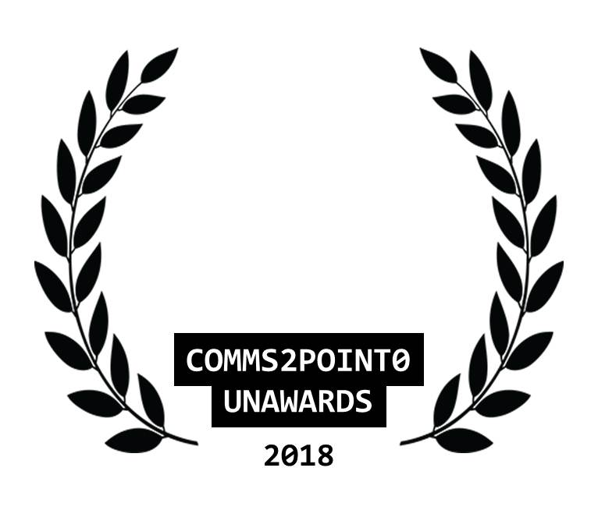
#UnAwards18 ENTRY // NOMINATION FORM
Please complete this entry form and email it to admin@comms2point0unawards.co.uk by 25 October 2018 (midnight)
You are able to send one piece of supporting information to help with your entry (but please only send one as our judges will not be able to look at any more than this) Thanks.
Your name | Nicole Kenny
Your email address | nicole.kenny@enwl.co.uk
Your organisational @twitter | @ElectricityNW
Your personal @twitter [optional] | @Nicole_Kenny
Category entered | BEST COMMS/DIGITAL TEAM
Name of organisation/team/individual being entered/nominated | Electricity North West
Name of entry | Powering our communities
Date project delivered [to / from] | Past three years 2015 - 2018
Campaign/project budget | Total comms budget = c£500k
Brief description of objectives | Electricity North West is the private company that owns, operates and maintains the region’s power network. Because there’s only one electricity network, used by all customers, we’re heavily regulated by the government via Ofgem.  2015-18 were the first three years of a new eight-year ‘price control’ period where Ofgem agree how much we can charge customers for our service. This price control was tougher than the last with increased emphasis on stakeholder engagement and scrutiny, putting comms in the spotlight.  We have used our comms budget effectively, succeeding in every measure year on year for the past three years. Our work directly affects the revenue we earn from Ofgem and our return to shareholders, including earning more than £2m from Ofgem’s stakeholder engagement incentive over the past three years.  For the past three years the comms team has supported the business aims through the following SMART objectives:  1. Improve our reputation and ‘ease of contact’ for customers to maximise our performance (measured by customer surveys and Ofgem incentive).  2. Raise awareness and understanding of our role to get closer to customers (measured by customer surveys).  3. Enhance corporate responsibility work to manage risk and get ready for the next price control (measured by the Business in the Community CR Index).  4. Improve our stakeholder engagement helping meet all four business objectives (measured by Ofgem incentive).  5. Improve employee engagement, to maximise performance, reduce risk and get ready for our next price control (measured by employee surveys).
Brief outline of strategy/plan | Our business has four strategic aims:  1. Maximise performance  2. Get closer to customers  3. Reduce and manage risk  4. Get ready for our next price control (2023-2028).  The business aims have been supported by a comms team of nine people providing three fully integrated awareness campaigns, as well as the full comms mix including media relations, marketing, digital, internal comms, crisis comms, a 24hr press office and stakeholder engagement.
What did you deliver and how did you measure it? | Over the past three years we have run three awareness campaigns as well as ongoing media and stakeholder relations to support our business’ strategic aims.  Success has been measured through paid-for research and organic analytics on a weekly, monthly and yearly basis.  Clear goals for across the team include:  Goal  Developed and embedded a new purpose and principles  Increase no. of colleagues completing stakeholder tracker  Increase no. of engagements tracked  Reputation (% of customers who believe Electricity North West has a good reputation)  Ease of contact  Positive/balanced media coverage reach  Coverage – positive/balanced sentiment  Social coverage – positive/balanced sentiment
What were the outcomes/benefits? | We achieved our highest ever scores in 2018 for the following regularly-reported SMART comms objectives:  - 58% of customers think we have a good reputation, up from 44% in 2015, and 73% of customers think it is easy to get in touch with us, up from 61% in 2015.  - 63% of customers now recognise who we are, up from 41% in 2015 and 35% of customers understand what we do, up from 11% in 2015.  - We earned the business £700k scoring 64% in Ofgem’s stakeholder engagement incentive in 2017, up from 61% in 2015.  - We scored 92% in Business in the Community’s CR index in 2018, up from 79% in 2015.  - Our employee engagement scores have risen to 72% in 2018, up from 42% in 2013.  As well as all this activity we have also recently:  - delivered and embedded a new company-wide employee-led purpose and set of principles internally in 2018, improving employee engagement;  - re-launched our website in 2017 after two years of business engagement and development, resulting in a more streamlined customer journey and increased employee involvement, reducing risk and improving efficiency;  - launched a new national 105 power cut emergency number with other networks in 2016, making it easier for customers to contact us. We are now the leading network for calls using this number, with 60% of our calls now coming via 105.  - managed a potentially damaging Health and Safety Executive prosecution case by liaising closely with the business, legal teams and local media where appropriate, resulting in us managing reputational risks;  - responded to six storms, particularly March 2018’s Storm Emma which combined with the ‘Beast from the East’ leaving 23,000 properties without power across Cumbria, Lancashire and Greater Manchester. Our proactive approach resulted in improved reputation in some areas; and  - led a company-wide rebrand in 2017 to create more contemporary look and feel to help us get closer to customers.
Tell us why you should win  [in no more than 100 words] | We care passionately about our role and our impact on the business. We’re operating within an industry which is changing at a rapid rate whilst also trying to rebuild trust and enhance the industry’s reputation.  We’ve shown our true value in supporting the organisation during normal working and more importantly during a crisis. We protect the business’ reputation and earn trust through the exceptional commitment and professionalism of our energetic and determined team.  Our proactive, engaging approach has not been easily won, but we continue to demonstrate the real value of PR, by earning trust to drive the business to meet its goals.

