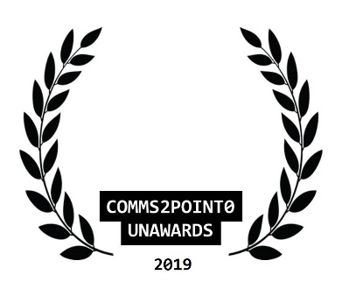
#UnAwards19 ENTRY // NOMINATION FORM
Please complete this entry form and email it to admin@comms2point0unawards.co.uk by 30 October 2019 (midnight)
You are able to send one piece of supporting information to help with your entry (but please only send one as our judges will not be able to look at any more than this) Thanks.
your name | Carol Brooker
your email address | carol@onezero.co.uk
your organisational @twitter
your personal @twitter [optional] | @Brooker_Carol
category entered | Life Time Achievement Award
name of organisation/team/individual being entered/nominated | Individual - Carol Brooker
name of entry | Heatherwood Hospital, Ascot
date project delivered [to / from] | 1994 to 2019
campaign/project budget | <£5k for banners, leaflets, meeting spaces, etc – my work completely pro bono for 25 years.
brief description of objectives | Monitor and promote quality healthcare in the community and ensure continuity of service on behalf of residents and community by involving multiple stakeholders.
brief outline of strategy/plan | Pioneered various campaigns in the media which has supported the continuance of Heatherwood Hospital in a period of significant change.
what did you deliver and how did you measure it? | 40,000 signatures 1994-5  Achieved provision of low risk maternity unit and children’s service 1994/5 until Autumn 2011 (which was due to be closed – a 15 year extension to services).  25,000 signatures 2012 – proposed umbrella group of 5 community groups called Save Heatherwood Hospital (SHH). I supported comms across mixed media and areas.  Out of 4 proposals in 2012 – Heatherwood Hospital was due to be demolished.
what were the outcomes/benefits? | In January 2019 (see my profile Twitter feed tweet on 27 January to Neil Dardis CEO of the Trust – FHFT) –  “£98m new build announced for Heatherwood Hospital – to be ready by 2021”.
tell us why you should win  [in no more than 100 words] | Passion and perseverance in the face of naysayers – had a vision for the hospital and needs of residents which I remained faithful to. Recognised the need to communicate this independently (without fear or favour) yet also collaborated with and was assisted by many others to whom I and our community owe a great deal: then, now and in the future.
NEW  comms2point0 are looking to build a new ‘’best practice resource with CAN Digital.  Are you happy for this entry to feature here? Thanks. | No

