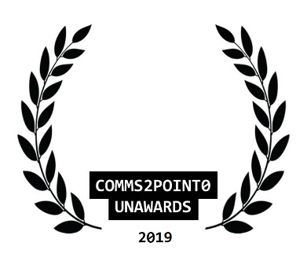
#UnAwards19 ENTRY // NOMINATION FORM
Please complete this entry form and email it to admin@comms2point0unawards.co.uk by 30 October 2019 (midnight)
You are able to send one piece of supporting information to help with your entry (but please only send one as our judges will not be able to look at any more than this) Thanks.
your name | Niall Walsh
your email address | niall.walsh@liverpool.gov.uk
your organisational @twitter | @lpoolcouncil
your personal @twitter [optional] | @Chatmandu
category entered | Best Comms / Digital Team
name of organisation/team/individual being entered/nominated | Liverpool City Council
name of entry | Liverpool City Council 2019
date project delivered [to / from] | January onwards
campaign/project budget | 0
brief description of objectives | 2019 was partly about playing catchup with other councils with regards to comms under the direction of our newly appointed Communications Director - we have really focused our efforts on expanding our range of social media channels and generating more of our own content
brief outline of strategy/plan
what did you deliver and how did you measure it?
what were the outcomes/benefits?
tell us why you should win  [in no more than 100 words] | - Twitter video views have increased by over 1,000,000 in the space of 9 months.  - Monthly Twitter impressions have doubled  - Twitter engagement rate has doubled  - Facebook and Instagram accounts launched and adding hundreds of new followers month on month  - merseyviews.co.uk blog launched with an average of 3000 impressions per month  - merseywaves.co.uk podcast launched with an average of 750 listeners per episode  - Traffic to liverpoolexpress.co.uk has doubled  - Twice daily internal news briefing launched  - Delivered comms seen around the world supporting the LFC Champions League parade https://www.prweek.com/article/1586547/liverpool-champions-league-triumph-gives-incalculable-pr-boost-city-says-council
NEW  comms2point0 are looking to build a new ‘’best practice resource with CAN Digital.  Are you happy for this entry to feature here? Thanks. | Yes or No

