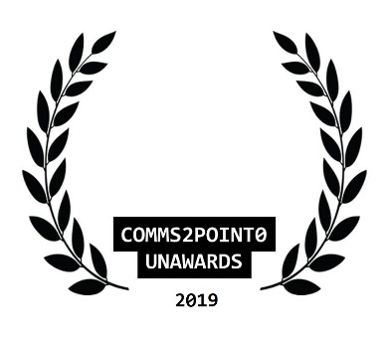
#UnAwards19 ENTRY // NOMINATION FORM
Please complete this entry form and email it to admin@comms2point0unawards.co.uk by 30 October 2019 (midnight)
You are able to send one piece of supporting information to help with your entry (but please only send one as our judges will not be able to look at any more than this) Thanks.
your name | Lisa Potter
your email address | lisapotter@lawscot.org.uk
your organisational @twitter
your personal @twitter [optional] | @crystal23tipps
category entered | Lifetime Achievement Award
name of organisation/team/individual being entered/nominated | Ruth Fry, Corporate Communications Manager, Perth & Kinross Council
name of entry
date project delivered [to / from]
campaign/project budget

brief description of objectives

brief outline of strategy/plan
what did you deliver and how did you measure it?

what were the outcomes/benefits?

tell us why you should win  [in no more than 100 words] | With over 18 years experience in public relations – mainly in the public sector – Ruth maintains a commitment to the importance of taking a strategic approach to communications in the face of all obstacles.  Ruth is passionate about her career. She shares that passion with every member of her team, and fights their corner across the organisation.  She blazed a trail in introducing the first annual communications plan for Perth & Kinross Council. A key document which, for the first time, got agreement from senior managers to a specific list of priority projects. All of these projects had to meet the key criteria that there was an identified budget, and SMART objectives which reflected the need for behavioural change or another demonstrable outcome which the communications and design team could achieve.  Ruth’s persuasive powers to get sign off for this document, and to support the team in implementing it in the first year cannot be overstated. Finally it provided an opportunity to set a clear agenda on what professional communications could and should look like within the organisation.  All this alongside dealing with major projects on an unprecedented scale, including the (unfortunately ultimately unsuccessful) bid for Perth to be named UK City of Culture 2021.  Outwith the day job Ruth’s commitment to professional communications continues. A former CIPR Scotland Committee member and a former communications and marketing lead for Perth Credit Union, Ruth is keen to share her skills to aid others.  She is also a contributor for LGiU Scotland, helping local government colleagues across Scotland understand emerging issues by providing readable summaries of briefings accessed by LGiU member organisations across the country.  In addition she contributed a very thought-provoking chapter to the CIPR Platinum publication, celebrating 70 years of the membership body. The topic – Community co-creation as a means of public relations – was perfect for Ruth, demonstrating the scope of what public relations means to her.
NEW  comms2point0 are looking to build a new ‘’best practice resource with CAN Digital.  Are you happy for this entry to feature here? Thanks. | Yes or No

